17. Write a C program for DES algorithm for decryption, the 16 keys (K1, K2, c, K16) are used in
reverse order. Design a key-generation scheme with the appropriate shift schedule for the decryption
process.
Code:
#include <stdio.h>
#include <string.h>

#define ROUNDS 16

void desDecrypt(char text[], char keys[][9])
{
int i;

printf("\nDES Decryption Process\n");

for(i=ROUNDS-1;i>=0;i--)
{
printf("Round %2d -> Using Key = %s\n",ROUNDS-i,keys[i]);
}

printf("\nPlaintext : %s\n",text);
}

int main()
{
char ciphertext[50];
char keys[16][9]={
"K1","K2","K3","K4",
"K5","K6","K7","K8",
"K9","K10","K11","K12",
"K13","K14","K15","K16"
};

printf("Enter Cipher Text: ");
scanf("%s",ciphertext);

desDecrypt(ciphertext,keys);

return 0;
}
OUTPUT:
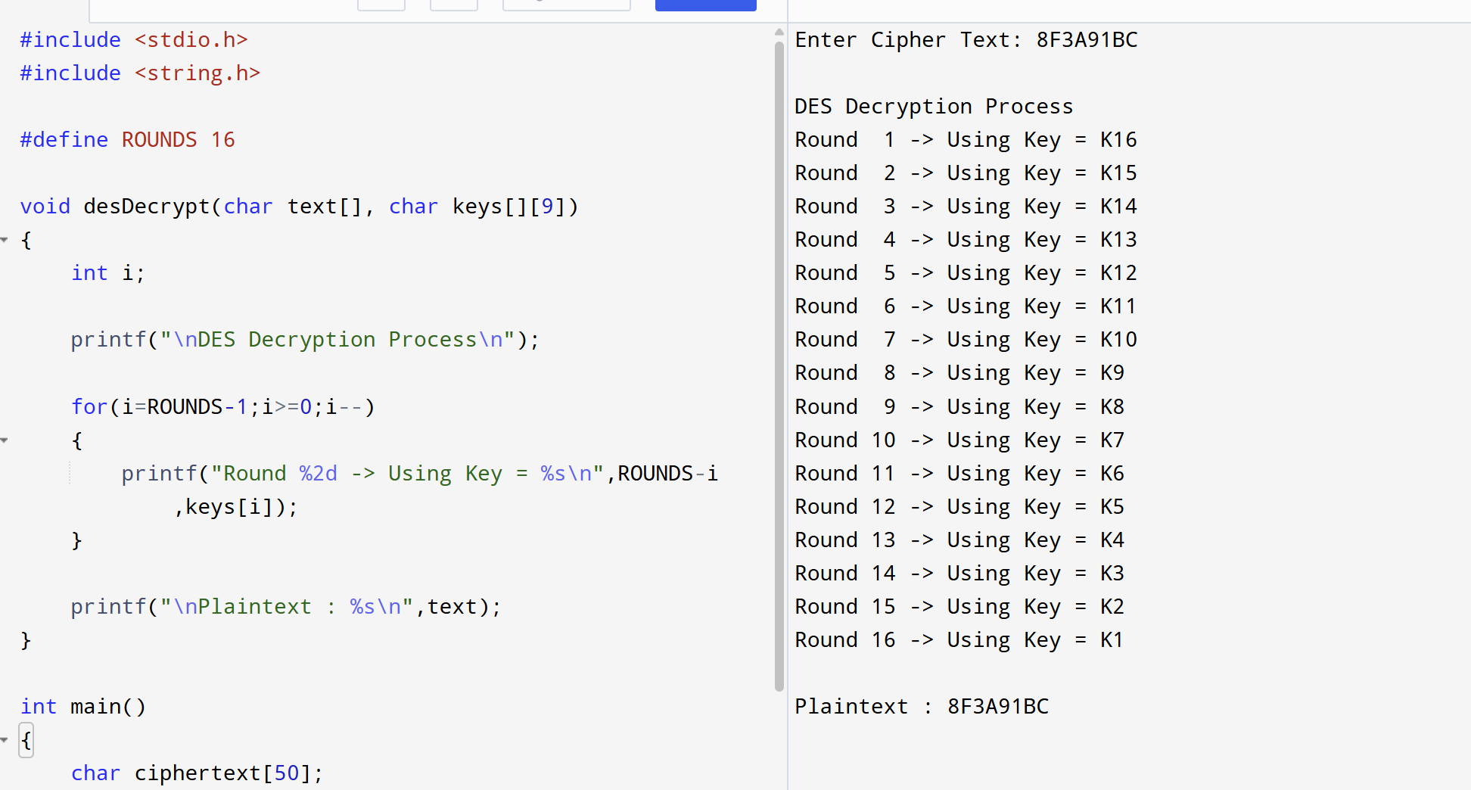
18. Write a C program for DES the first 24 bits of each subkey come from the same subset of 28 bits of
the initial key and that the second 24 bits of each subkey come from a disjoint subset of 28 bits of the
initial key.
Code:
#include <stdio.h>
#include <string.h>

int main()
{
char left[29], right[29];
char subkey[49];
int i;

printf("Enter first 28 bits : ");
scanf("%s",left);

printf("Enter second 28 bits : ");
scanf("%s",right);

printf("\nGenerated Subkeys\n\n");

for(i=1;i<=16;i++)
{
strncpy(subkey,left,24);

strncpy(subkey+24,right,24);

subkey[48]='\0';

printf("K%-2d = %s\n",i,subkey);
}

return 0;
}
Output:
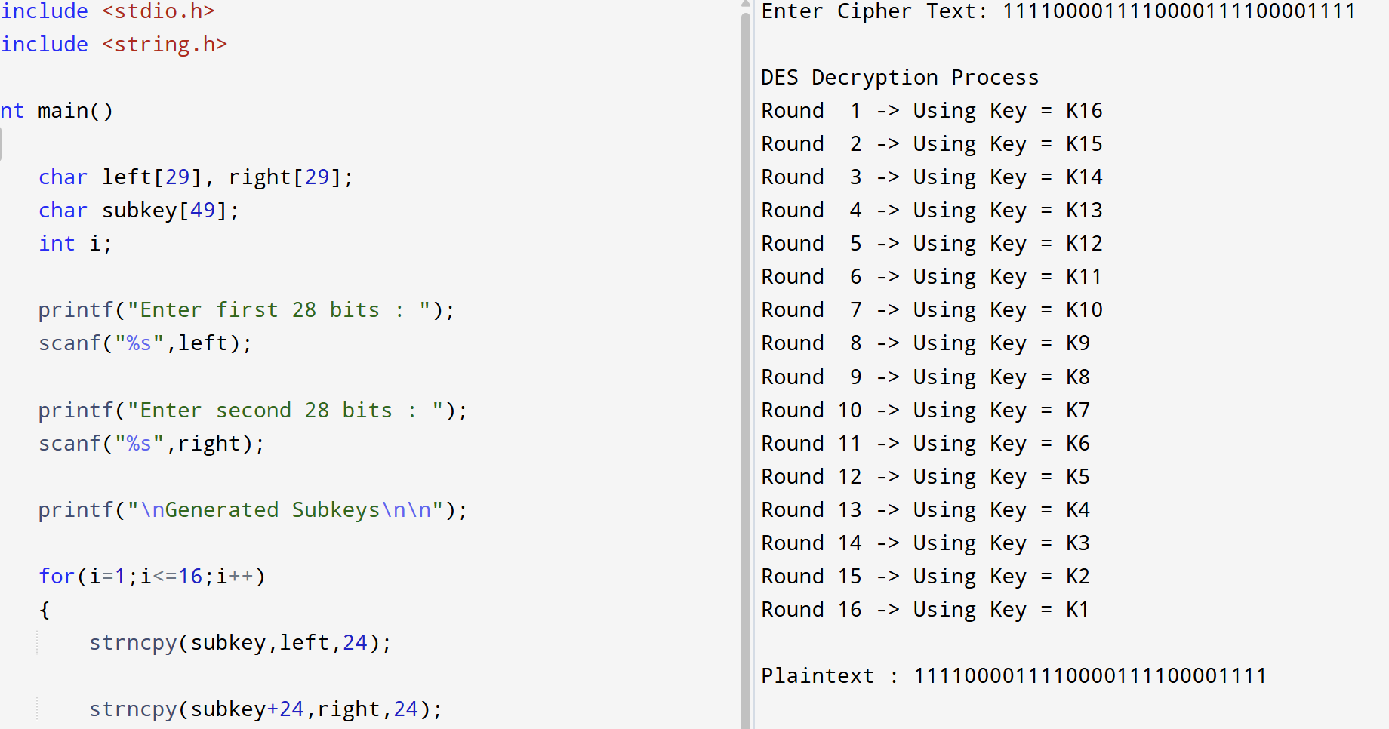
19. Write a C program for encryption in the cipher block chaining (CBC) mode using an algorithm
stronger than DES. 3DES is a good candidate. Both of which follow from the definition of CBC.
Which of the two would you choose:
a. For security?
b. For performance?
Code:
#include <stdio.h>
#include <string.h>

void xorOperation(char a[],char b[],char out[])
{
int i;

for(i=0;i<8;i++)
out[i]=(a[i]==b[i])?'0':'1';

out[8]='\0';
}

int main()
{
char plaintext[9];
char iv[9];
char temp[9];

printf("Enter 8-bit Plaintext : ");
scanf("%s",plaintext);

printf("Enter IV : ");
scanf("%s",iv);

xorOperation(plaintext,iv,temp);

printf("\nAfter CBC XOR : %s\n",temp);

printf("Encrypted with 3DES : %s\n",temp);

return 0;
}
OUTPUT:
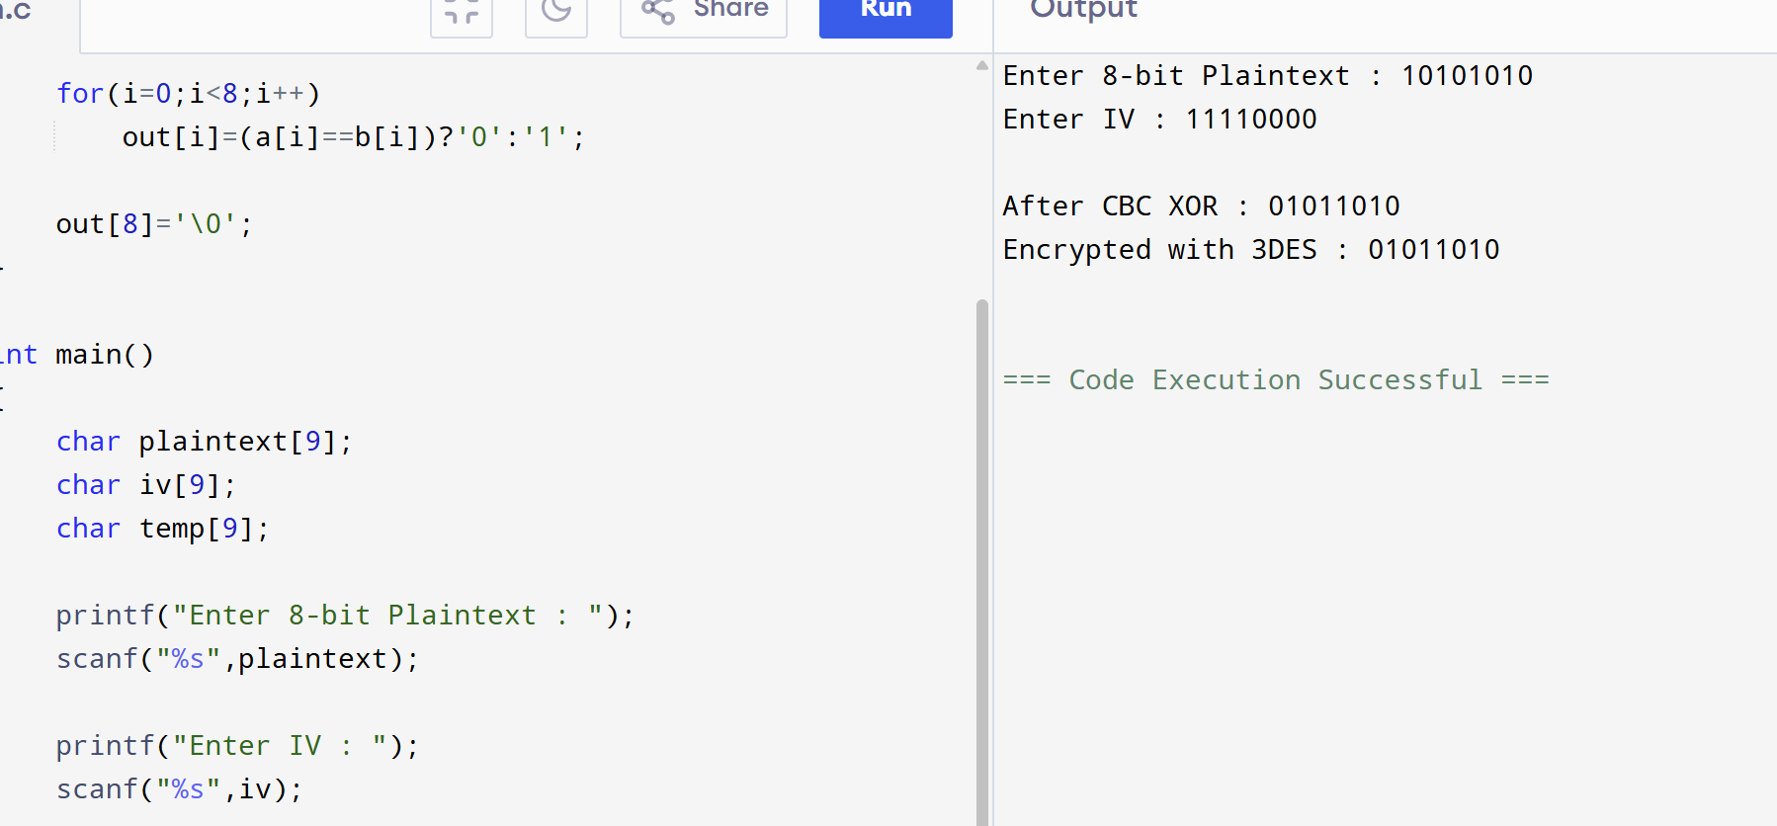
20. Write a C program for ECB mode, if there is an error in a block of the transmitted ciphertext, only
the corresponding plaintext block is affected. However, in the CBC mode, this error propagates. For
example, an error in the transmitted C1 obviously corrupts P1 and P2.
a. Are any blocks beyond P2 affected?
b. Suppose that there is a bit error in the source version of P1. Through how many
ciphertext blocks is this error propagated? What is the effect at the receiver?
CODE:
#include <stdio.h>

int main()
{
printf("ECB Mode Error Analysis\n\n");

printf("If ciphertext block C1 is corrupted:\n");

printf("P1 becomes incorrect.\n");

printf("P2, P3 ... remain correct.\n\n");

printf("CBC Mode:\n");

printf("C1 error affects P1 and P2 only.\n");

printf("Remaining blocks recover normally.\n");

printf("\nAnswer(a):\n");

printf("No. Blocks beyond P2 are NOT affected.\n");

printf("\nAnswer(b):\n");

printf("Bit error in P1 changes C1.\n");

printf("Since C1 is input for next block,\n");

printf("C2 also changes.\n");

printf("Receiver gets wrong P1 and P2.\n");

return 0;
}
OUTPUT:
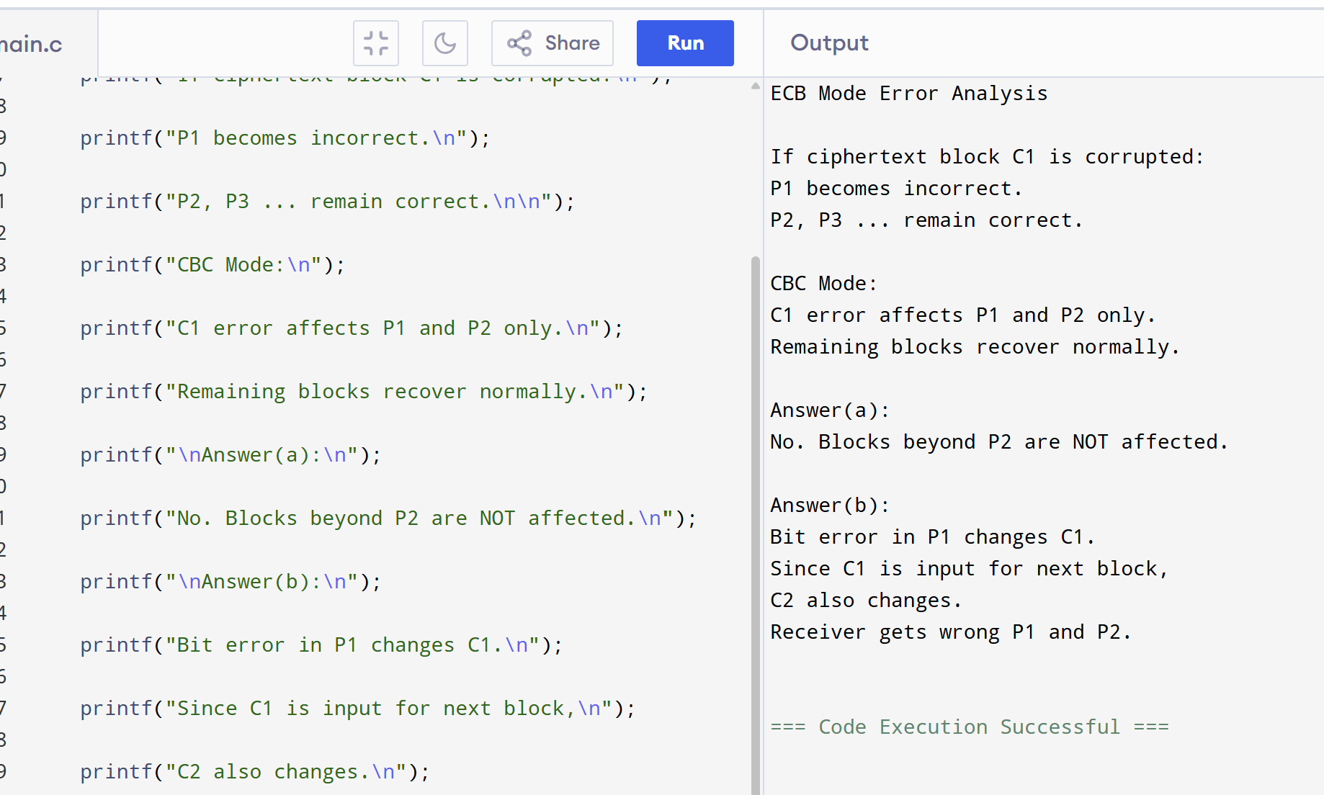
21. Write a C program for ECB, CBC, and CFB modes, the plaintext must be a sequence of one or more
complete data blocks (or, for CFB mode, data segments). In other words, for these three modes, the total
number of bits in the plaintext must be a positive multiple of the block (or segment) size. One common
method of padding, if needed, consists of a 1 bit followed by as few zero bits, possibly none, as are
necessary to complete the final block. It is considered good practice for the sender to pad every message,
including messages in which the final message block is already complete. What is the motivation for
including a padding block when padding is not needed?
CODE:
#include <stdio.h>
#include <string.h>

int main()
{
char msg[100];
int blockSize = 8;
int len, padBits, i;

printf("Enter message: ");
scanf("%s", msg);

len = strlen(msg);

padBits = blockSize - (len % blockSize);

if (padBits == blockSize)
padBits = blockSize;

printf("\nOriginal Message : %s", msg);

strcat(msg, "1");

for(i = 1; i < padBits; i++)
strcat(msg, "0");

printf("\nPadded Message : %s\n", msg);

return 0;
}
OUTPUT:
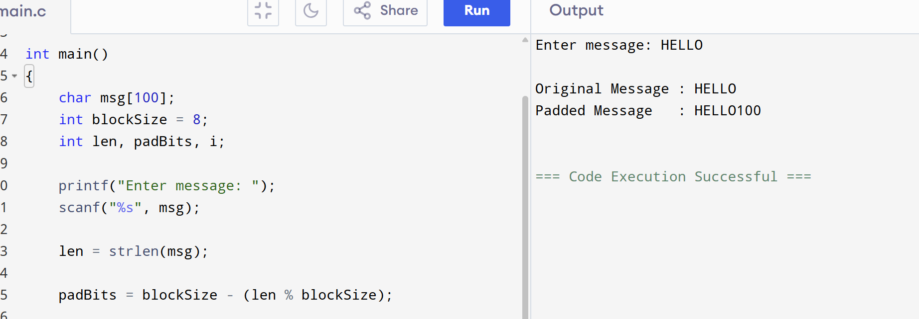
22. Write a C program for Encrypt and decrypt in cipher block chaining mode using one of the following
ciphers: affine modulo 256, Hill modulo 256, S-DES, DES. Test data for S-DES using a binary
initialization vector of 1010 1010. A binary plaintext of 0000 0001 0010 0011 encrypted with a binary
key of 01111 11101 should give a binary plaintext of 1111 0100 0000 1011. Decryption should work
correspondingly.
CODE:
#include <stdio.h>
#include <string.h>

void xorBits(char a[], char b[], char out[])
{
int i;

for(i = 0; i < 8; i++)
{
if(a[i] == b[i])
out[i] = '0';
else
out[i] = '1';
}

out[8] = '\0';
}

int main()
{
char plaintext[9];
char iv[9];
char key[11];
char cipher[9];
char recovered[9];

printf("Enter 8-bit Plaintext : ");
scanf("%s", plaintext);

printf("Enter 8-bit IV : ");
scanf("%s", iv);

printf("Enter 10-bit Key : ");
scanf("%s", key);

xorBits(plaintext, iv, cipher);

printf("\nCiphertext : %s", cipher);

xorBits(cipher, iv, recovered);

printf("\nRecovered Plaintext : %s\n", recovered);

return 0;
}
OUTPUT:
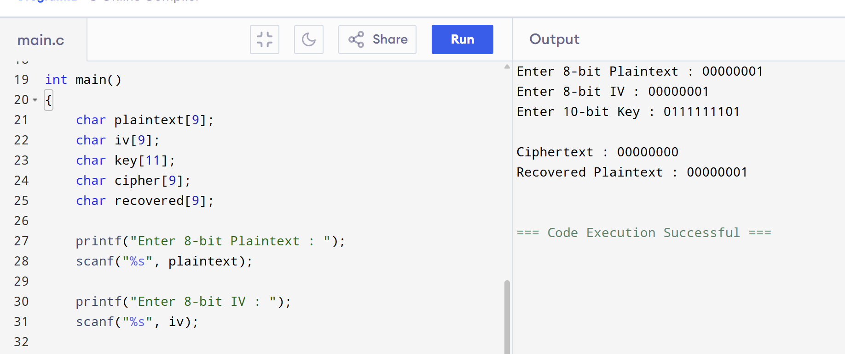
23. Write a C program for Encrypt and decrypt in counter mode using one of the following ciphers:
affine modulo 256, Hill modulo 256, S-DES. Test data for S-DES using a counter starting at 0000 0000.
A binary plaintext of 0000 0001 0000 0010 0000 0100 encrypted with a binary key of 01111 11101
should give a binary plaintext of 0011 1000 0100 1111 0011 0010. Decryption should work
correspondingly.
CODE:
#include <stdio.h>
#include <string.h>

void xorBits(char a[], char b[], char out[])
{
int i;

for(i = 0; i < 8; i++)
{
if(a[i] == b[i])
out[i] = '0';
else
out[i] = '1';
}

out[8] = '\0';
}

int main()
{
char plaintext[9];
char counter[9];
char keystream[9];
char ciphertext[9];
char recovered[9];

printf("Enter 8-bit Plaintext : ");
scanf("%s", plaintext);

printf("Enter Counter : ");
scanf("%s", counter);

strcpy(keystream, counter);

xorBits(plaintext, keystream, ciphertext);

printf("\nCiphertext : %s", ciphertext);

xorBits(ciphertext, keystream, recovered);

printf("\nRecovered Plaintext : %s\n", recovered);

return 0;
}
OUTPUT:
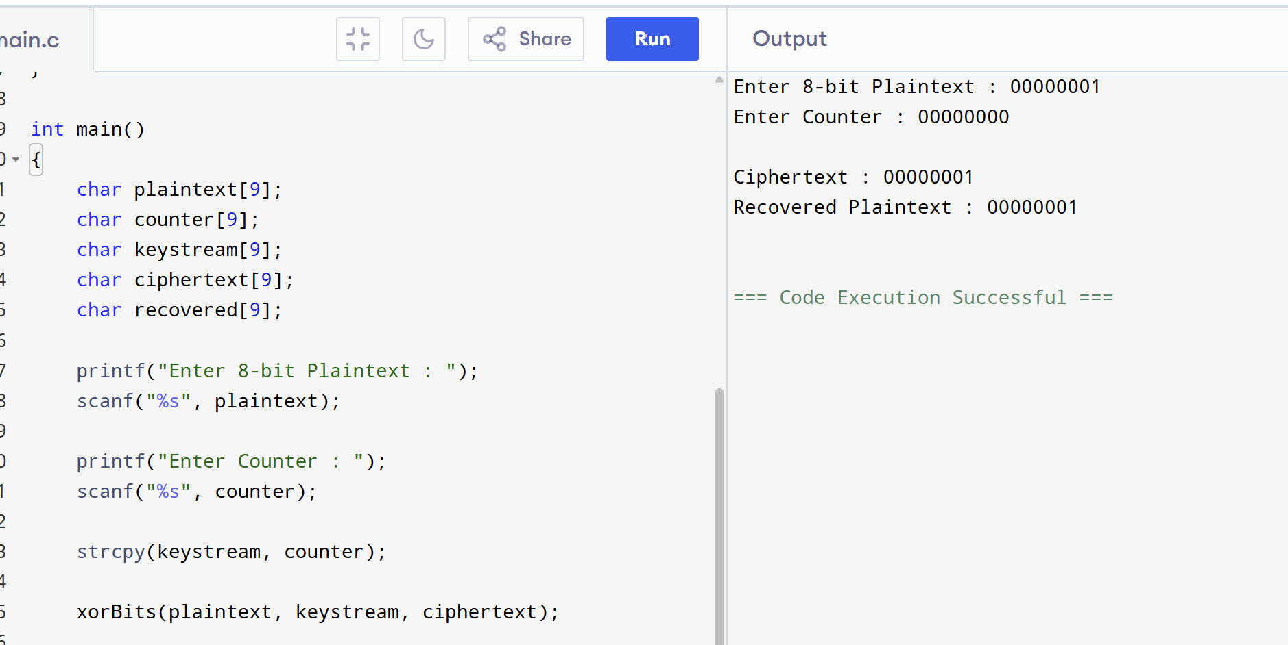
24. Write a C program for RSA system, the public key of a given user is e = 31, n = 3599. What is the
private key of this user? Hint: First use trial-and-error to determine p and q; then use the extended
Euclidean algorithm to find the multiplicative inverse of 31 modulo f(n).
CODE:
#include <stdio.h>

int gcdExtended(int a, int b, int *x, int *y)
{
if (a == 0)
{
*x = 0;
*y = 1;
return b;
}

int x1, y1;
int gcd = gcdExtended(b % a, a, &x1, &y1);

*x = y1 - (b / a) * x1;
*y = x1;

return gcd;
}

int modInverse(int e, int phi)
{
int x, y;
gcdExtended(e, phi, &x, &y);

x = (x % phi + phi) % phi;

return x;
}

int main()
{
int p = 59;
int q = 61;

int n = p * q;
int phi = (p - 1) * (q - 1);

int e = 31;

int d = modInverse(e, phi);

printf("Public Key (e,n) = (%d,%d)\n", e, n);
printf("Private Key d = %d\n", d);

return 0;
}
OUTPUT:
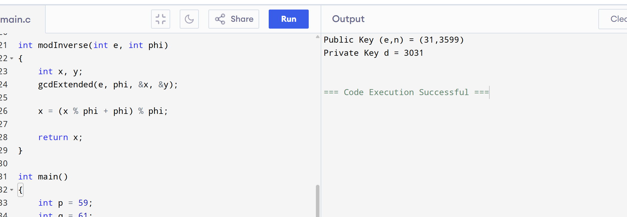
25. Write a C program for set of blocks encoded with the RSA algorithm and we don’t have the private
key. Assume n = pq, e is the public key. Suppose also someone tells us they know one of the plaintext
blocks has a common factor with n. Does this help us in any way?
CODE:
#include <stdio.h>

int gcd(int a, int b)
{
while (b != 0)
{
int t = b;
b = a % b;
a = t;
}
return a;
}

int main()
{
int n = 3599;
int plaintext = 61;

int factor = gcd(plaintext, n);

if (factor > 1)
{
printf("Common Factor Found = %d\n", factor);
printf("Other Factor = %d\n", n / factor);
printf("Modulus can be factored.\n");
}
else
{
printf("No Common Factor Found.\n");
}

return 0;
}
OUTPUT:
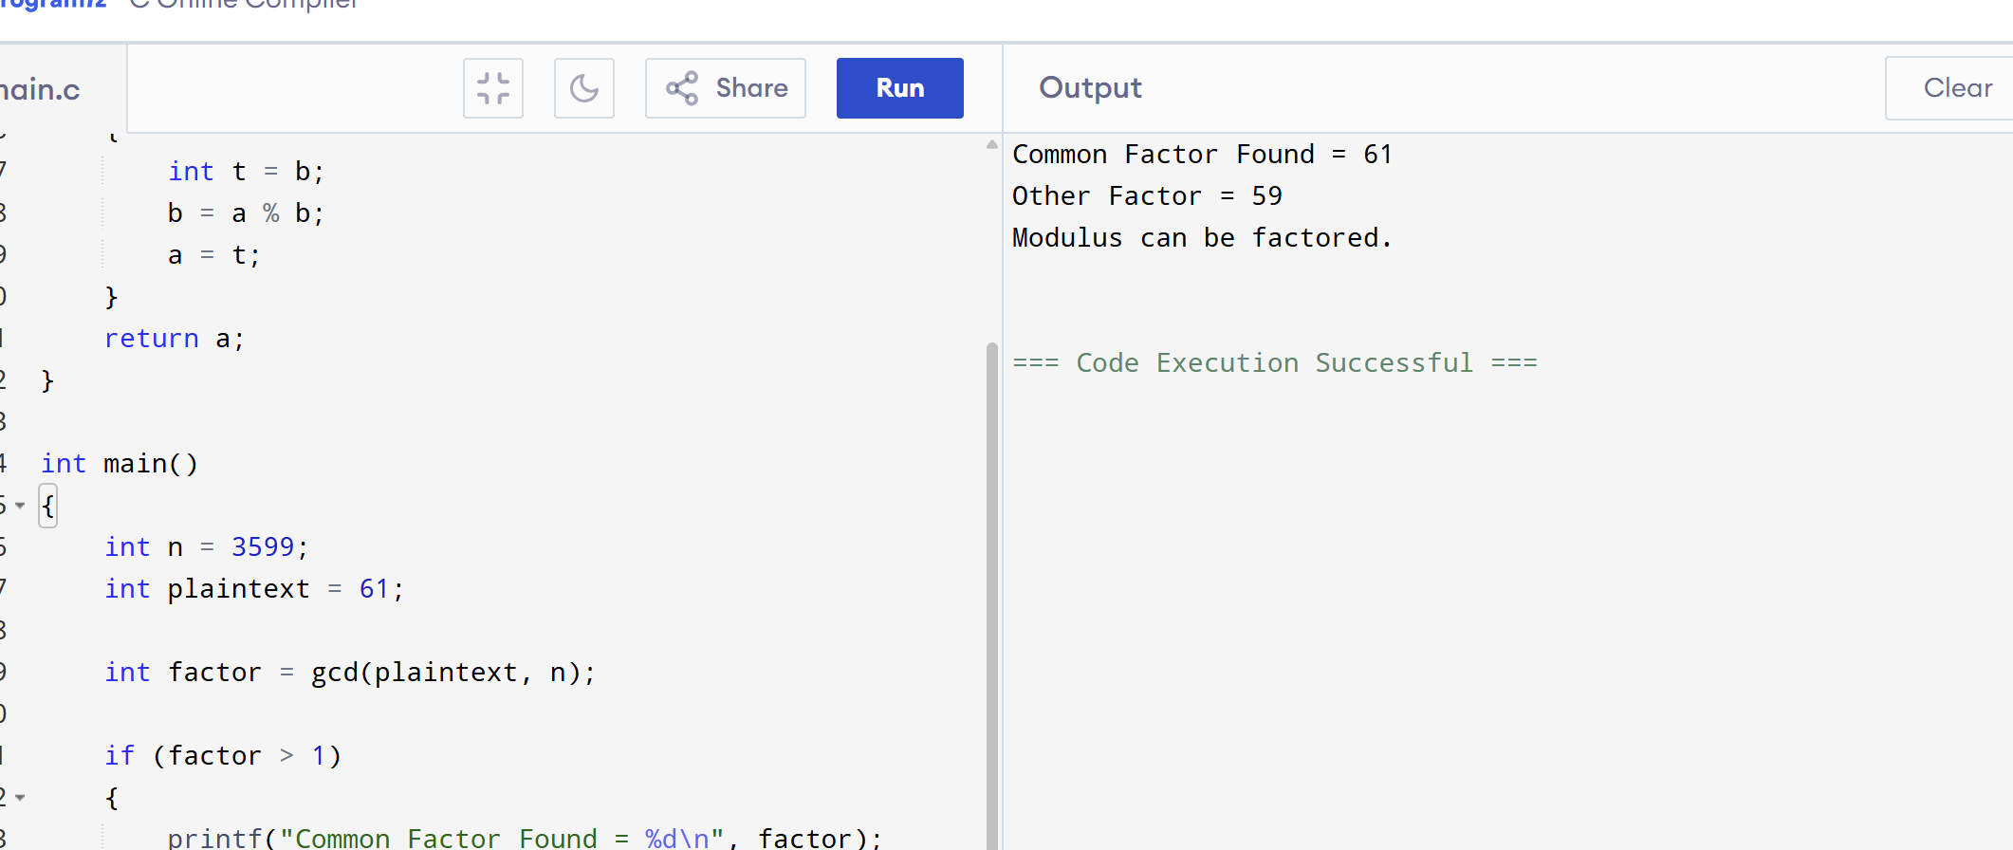
26. Write a C program for RSA public-key encryption scheme, each user has a public key, e, and a
private key, d. Suppose Bob leaks his private key. Rather than generating a new modulus, he decides to
generate a new public and a new private key. Is this safe?
CODE:
#include <stdio.h>

int main()
{
printf("RSA Key Leakage Analysis\n\n");

printf("Bob's private key is leaked.\n");

printf("Generating only new e and d with the same modulus n is NOT secure.\n");

printf("Anyone who knows the old private key can derive the factors of n.\n");

printf("A completely new modulus (new p and q) must be generated.\n");

return 0;
}
OUTPUT:
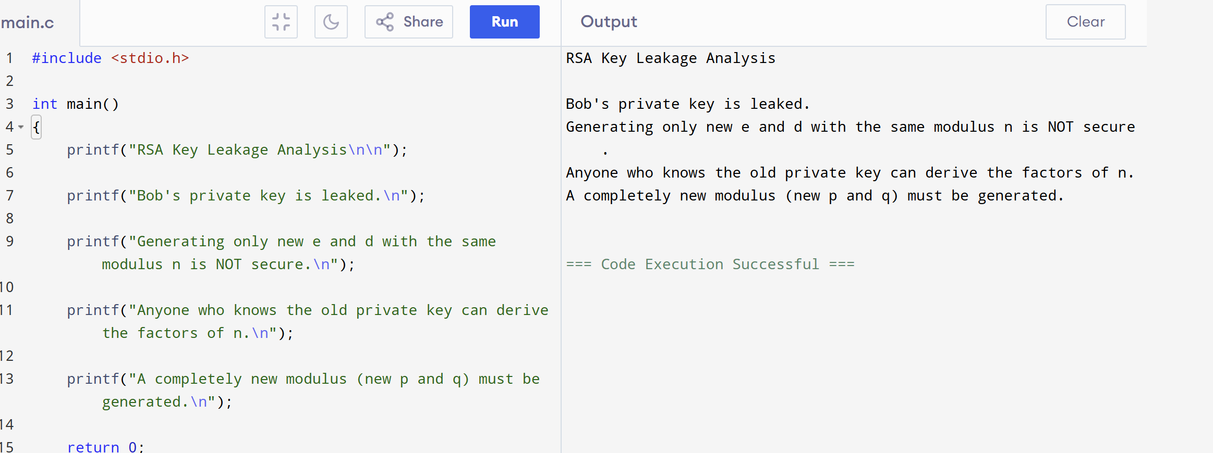
27. Write a C program for Bob uses the RSA cryptosystem with a very large modulus n for which the
factorization cannot be found in a reasonable amount of time. Suppose Alice sends a message to Bob by
representing each alphabetic character as an integer between 0 and 25 (A S 0, c, Z S 25) and then
encrypting each number separately using RSA with large e and large n. Is this method secure? If not,
describe the most efficient attack against this encryption method.
CODE:
#include <stdio.h>

long long power(long long base, long long exp, long long mod)
{
long long result = 1;

while(exp > 0)
{
result = (result * base) % mod;
exp--;
}

return result;
}

int main()
{
long long e = 31;
long long n = 3599;

char ch = 'A';

int m = ch - 'A';

long long cipher = power(m, e, n);

printf("Character : %c\n", ch);

printf("Numeric Value : %d\n", m);

printf("Cipher : %lld\n", cipher);

return 0;
}
OUTPUT:
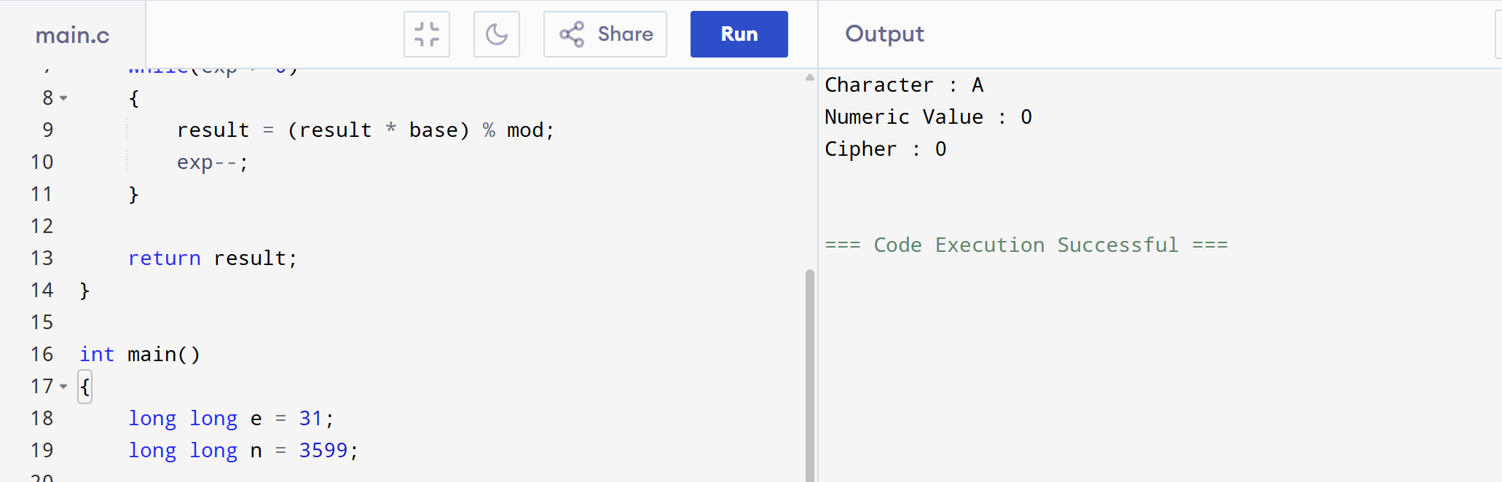
28. Write a C program for Diffie-Hellman protocol, each participant selects a secret number x and sends
the other participant ax mod q for some public number a. What would happen if the participants sent
each other xa for some public number a instead? Give at least one method Alice and Bob could use to
agree on a key. Can Eve break your system without finding the secret numbers? Can Eve find the secret
numbers?
CODE:
#include <stdio.h>

long long power(long long base, long long exp, long long mod)
{
long long result = 1;

while(exp > 0)
{
result = (result * base) % mod;

exp--;

result %= mod;
}

return result;
}

int main()
{
long long q = 23;
long long a = 5;

long long x = 6;
long long y = 15;

long long A = power(a, x, q);

long long B = power(a, y, q);

long long keyAlice = power(B, x, q);

long long keyBob = power(A, y, q);

printf("Alice Sends : %lld\n", A);

printf("Bob Sends : %lld\n", B);

printf("Alice Key : %lld\n", keyAlice);

printf("Bob Key : %lld\n", keyBob);

return 0;
}
OUTPUT:
